Application and Information Packet

Yale New Haven Hospital
Martin Luther King Jr.

HIGH SCHOOL STUDENT
COMMUNITY SERVICE AWARD

Application Due Date: 12/30/2016

YALE-NEW HAVEN HOSPITAL/MARTIN LUTHER KING, JR
COMMUNITY SERVICE AWARD

In honor of the many accomplishments of Martin Luther King, Jr. and a strong belief in community service, Yale-New Haven Hospital is pleased to announce it will award its annual YNHH/Martin Luther King, Jr. Community Service Award. This grant will be presented to (3) three New Haven residents attending a New Haven public high school who have demonstrated 40 hours or more of community service. The award will be a one-time award of $1000 for each of the (3) students selected.

Each New Haven Public High School is requested to encourage its students to apply for the Yale-New Haven Hospital/Martin Luther King, Jr. Community Service Award. The final selection of the recipients will be made by the Yale-New Haven Hospital Community Service Award Committee.

The criteria for selection are:

- Students must be a New Haven resident and attend a high school in the New Haven public school system.

- Students must have accumulated 40 hours or more of community service during the year for which they have not received school credit or any type of compensation.

Please read this information packet for the details regarding this annual award.

The deadline for submission is December 30, 2016. All applications and accompanying letters may be scanned and submitted via email or mailed to me by December 6, 2016:

Cynthia Lowman
Yale New Haven Health System
Yale-New Haven Hospital – CB 1007C
Talent Acquisition Department
20 York Street
New Haven, CT 06510
Cynthia.Lowman@ynhh.org

The award recipients will be awarded their check on January 20, 2017.

YALE-NEW HAVEN HOSPITAL/MARTIN LUTHER KING, JR.
COMMUNITY SERVICE AWARD

Application Process
& Check List

Each High School student must submit the following:

- Application completed by student
- Three (3) References: (20%)
      - One (1) must be from an individual, agency or organization for which the student provided community service.
      - One (1) must be from a member of the student’s high school faculty addressing the student’s attendance, attitude, civic-mindedness and ability to work with others.
      - One (1) student’s choice

    - A 600 word essay: (50%)
      - Essay should give a detailed account of the student’s community service experience describing how their experience(s) influenced their sensitivity and respect for differences in others. In addition, research Dr. Martin Luther King Jr. and share what you have learned from his efforts.

(Note the remaining 30% will be based on the extent/scope of the student’s community service and their research about Dr. Martin Luther King Jr.)

To complete the application – Click in the grey area of the application, type in your information. Save the document using your full name, for e.g. John Smith’s Martin Luther King Jr.’s Community Service Application and then forward the completed application to your school contact person, they will email the application to the Yale New Haven Hospital contact person.

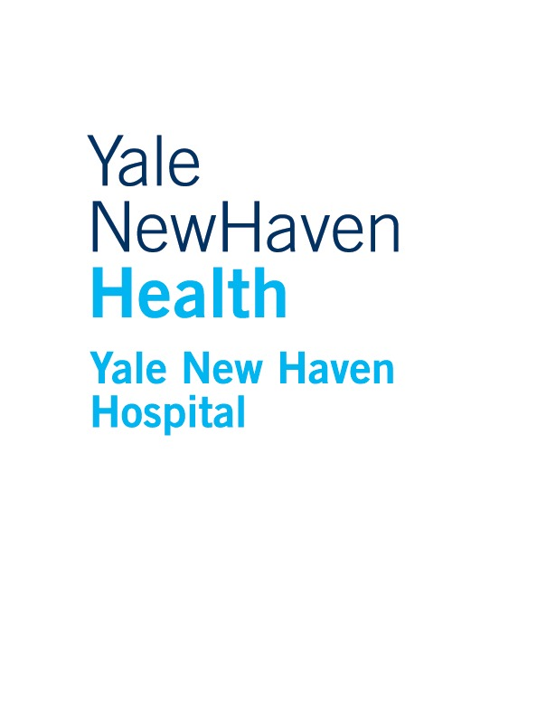

Martin Luther King, Jr.
Community Service Award
Electronic Application
STUDENT APPLICATION

Due Date: December 30, 2016

TYPE OR PRINT ALL INFORMATION EXCEPT SIGNATURES
Please click in the grey box to type in the correct response in this electronic application, save with your full name and then email it to Cynthia.lowman@ynhh.org
Applicant Data: | Last Name First Middle Initial  Address Apt #  City State Zip  Telephone E-mail Address  Date of Birth (mo./day/yr.)
Parent or Guardian Information: | Last Name First Middle Initial  Address Apt #  City State Zip  Day Telephone E-mail Address Fax Relationship to Applicant
High School Data: | School Name HS Graduation Date  Address  City State Zip  Telephone
Community Volunteer Experience  (unpaid): | List all your community service experience(s) for the past 12 months with the date(s) and the number of hours you worked in each experience (Total hours must be 40 hours or greater). You will describe the experiences in your essay.
 | Community Service Experience (Use an additional sheet of paper if needed) | # of hours

Activities and Awards: | Please list all school activities in which you have participated in (e.g. student government, music, sports, etc.).
 | School Activities (Use an additional sheet of paper if needed)
Application  Checklist: | All application materials must be submitted to the YNHH/MLK Community Service Award Committee on time. Incomplete applications will not be evaluated. This application becomes complete and valid only when all the following materials are received:
Student Application signed by student, parent/guardian and School Official.
3 references:
1 from Community Service Agency/Organization where volunteered
1 from Faculty member of High School
1 your choice
Typed 300 word essay giving a detailed account of the student’s community service experience and describing how their experience(s) has influenced their sensitivity and respect for differences in others.
Certification: | Yale-New Haven Hospital has the sole responsibility for selecting the finalists based on criteria determined by the Yale-New Haven Hospital/Dr. Martin Luther King Community Service Award Committee.
 | I acknowledge decisions of Yale New Haven Hospital/Dr. Martin Luther King Community Service Award Committee are final. I certify that I meet the basic eligibility requirements of the award as described in the Application Packet and that the information provided is complete and accurate to the best of my knowledge. If requested, I agree to provide proof of information I have given on this form. This application becomes the property of Yale-New Haven Hospital/Dr. Martin Luther King Community Service Award Committee.
Applicant’s Signature Date
Parent/Guardian’s Signature Date
School Official’s Signature Date

